Ukraine Report

Maxim and Slavna Katz are leading this Uncharted initiative and they report that 28,000 Ukrainian immigrants have arrived in Israel and 32,000 Russians since the beginning of the war in Ukraine 11 months ago. For a country the size of Israel, in such a short amount of time, this presents many humanitarian issues. But the opportunities for presenting the gospel have been enormous.
Maxim says this: “Jesus is doing the miraculous with the Ukrainian people. This is one of the dark moments in their history but spiritually Jesus’ light is shining, and they are coming to salvation. It’s a spiritual awakening for the people of Ukraine in Israel, Poland and of course Ukraine.”

Ukraine and Poland-
The effect of the Russian attack has been devastating to the people and the church has weathered hardships. The trauma from the nearly one year old war has taken a toll on families. Along with that, there are power shortages, infrastructure breakdowns, and travel restrictions that have changed daily life.

Church Life- This church below is one we work with in Ukraine. Pastor Oleg and his wife Tamara are faithful servants and there is no heat or electricity in the church. This is typical in Ukraine and the people are bracing for a cold winter. Despite the difficulties, pastors like Oleg do huge amounts of counseling with devastated families and meet humanitarian needs with food, clothing, coats, medicine, and transportation.

Churches are full in Ukraine, and Poland with refugees still streaming in. We do not have a count of salvations, but we do know that they are numerous with baptisms also. One group that is especially open to the gospel are Ukrainian Jews. Praise God!

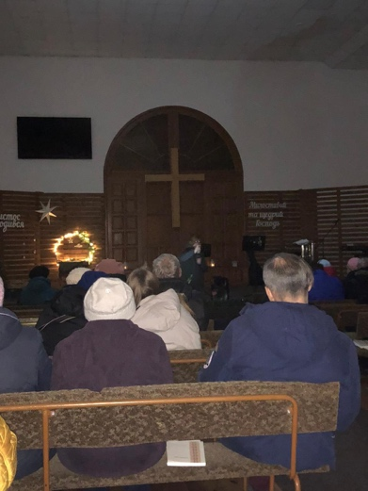

Pastors- The biggest prayer need is pastors who are discouraged and are fighting the urge to resign with the overwhelming and unanswerable needs of the people. Pastors are praying together, and we supported a retreat for them to get away for a few days to L’viv. This was a boost for them! We hope to do many more.

Rescues- There are still many rescues for women and their families in heavy war areas as their husbands are fighting for Ukraine in a war they don’t want. Pregnant women have been rescued and brought to safer places to deliver their babies. Brave Pastors and believers travel at their own risk to bring Ukrainians to the Western part of the country or into Poland to escape harms way. Uncharted through 100x’s Harvest helps fund many of these rescues.

Evangelism- Maxim Katz adds this: “The doors are wide open for the children and adults in Ukraine. There is a never-before-seen hunger for the Word of God. People are craving it as they are looking for help to make it through their day.

“The group of young people below were brought to a safe place in Ukraine and most of them have a father who was lost in the war or ones who are serving. Many broken hearts from the broken lives among these young people. Despite the hardships, our team was able to lead them in worship, Bible Study, fun games, and much needed counseling sessions both private and in group settings like the one below in the second picture. There were decisions for Christ as well!”

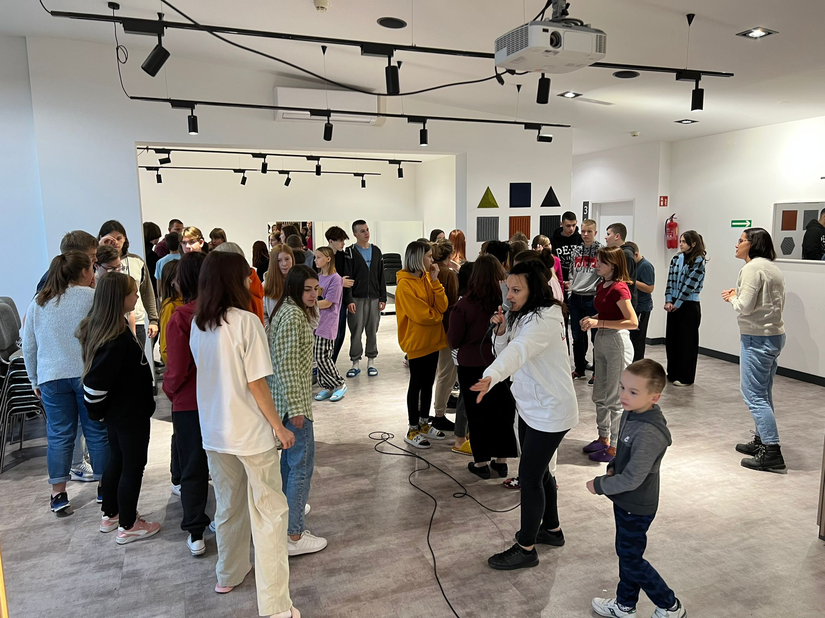

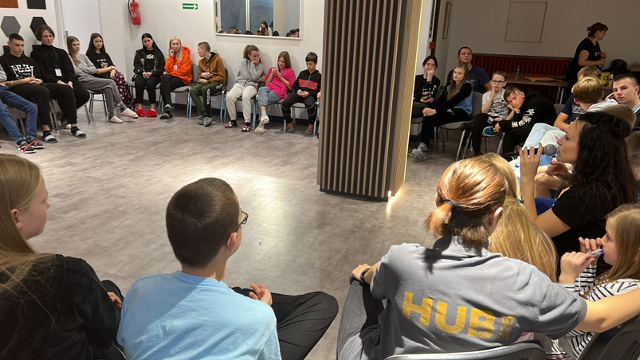

Israel-
The team has in recent months:
*Hosted a large event at Hadassah Hospital in Jerusalem for over 100 children from Ukraine who have cancer. Their families attended the fun Christmas celebration, and the gospel was preached to families and the staff at Israel’s most well-respected hospital. Many of the families had just arrived from Ukraine and are now getting involved with our team whose goal is to love them to Christ.

*Six Hanukkah Outreach Events were hosted for Ukrainian immigrants during the one-week December celebration and many Ukrainians are now coming to weekly Bible Studies and asking for personal visits from our team. There are Jewish believers from Ukraine but the majority who have arrived are atheists. So there is much work to do.

*Ukrainian Refugees in Okafim Many refugees from Ukraine are being relocated to the southern cities of Israel. There isn’t room in Jerusalem, and it is too expensive for the government to sustain them there. In Okafim, we just opened a new work and the mayor the city welcomed us at our first outreach event. They have seen the amount of humanitarian work we do around Israel and welcomed the team to help them with the Ukrainian move in’s who are coming weekly.
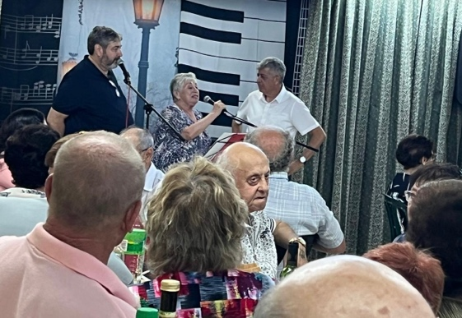

The Uncharted Israel team is absorbing large numbers of the immigrants in the four major regions of Israel- The Galilee, Mediterranean Coast, Jerusalem, and the Negev Desert.

All in all, the extreme generosity of 100x’s Harvest has provided rescues for those trapped in the crossfire of the war, large amounts of humanitarian aid, church strengthening, pastor support, counseling, youth support for those who’ve lost parents, gatherings for the adults dealing the loss of family members and so much more.

Without a doubt, the most important events taking place in Ukraine, Poland, and Israel are when desperate Ukrainians and Russians are responding to the Good News of Jesus Christ and making life commitments to follow Him as Savior.

For this we are eternally grateful. Thank you 100x’s Harvest for your heart for the gospel in Syria, Afghanistan, Ukraine, Poland, and Israel. You are a major force in providing resources to advance the Kingdom of God in these war-torn countries.

Tom Doyle-Uncharted Ministries
1/7/2023

